Optimization of Airfoil Design with Surrogate AI Modeling
Abstract: Airfoil design is one of the most complex challenges in aeronautical design [1]. Especially, because of the proportional nature of lift and drag, no airfoil is ideal for all cases, and the tradeoff between the two requires designers to reach a perfect balance. Reaching this balance, however, has never been an easy task, as traditional analysis relies on Computational Fluid Dynamics (CFD) [2], often using digital programs to perform calculations. While such calculations are generally accurate and effective, to do them on the scale necessary for airfoil design is slow and computationally expensive. A recent development in the field is Artificial Intelligence (AI) surrogate modeling to accelerate the speed of computation [3], but most hitherto existing studies rely on industrial-grade tools. This leaves open the possibility of widespread, open-source development of AI airfoil modeling. To address this gap, we explore how effectively small-scale AI models can replicate/improve upon aerodynamic optimization, through only open-source tools and parameterized geometry.
Existing literature explores the significance of both parameterization and modeling to enhance airfoil design, and some data is vital to the methodology here. Airfoil parameterization techniques provides a comprehensive analysis of options for parameterizing airfoils in simple methods [5]. Methods suggested for parameterization include the following: Bezier parameterization [6], which associates the airfoil with two Bezier curves, one each for the upper and lower airfoil surfaces; PARSEC parameterization [4], which we opt to use because of its sheer commonality, effectiveness, and simplicity of converting .PARSEC files to .dat files readable by XFOIL (and our model); the Sobieczky model [5], which is a modified PARSEC parameterization that attempts to fix issues with the trailing edge (though raising its own); and many alternatives involving some combination of these parameters. Additionally, various high-end efforts have been made to produce material in the field of airfoil design: AFBench, an aggregation of 200,000 airfoils produced using RTX-3090 GPUs running for 16 hours [7], PALMO, a NASA-sponsored machine learning benchmark done using the NASA High-End Compute Capability supercomputer (NASA) [8], as well as many other computing-intensive datasets designed for industrial applications. Such options, however, are unsuited to small-scale applications and do not necessarily benefit personal or startup use-cases without access to industry-grade platforms.
The possibilities of using machine learning and artificial intelligence to streamline airfoil optimization have also been explored. A recent review provides a comprehensive summary of the existing work regarding AI in airfoil and wing optimization [9], but again, primarily for final optimized results in large-scale applications, rather than the extraction of individual relationships, or small-scale AI modeling for airfoil design. We aim to use small samples from public datasets and simple scripts to assess the bottom-end limitations of AI for airfoil modeling, as well as to derive causal inferences about PARSEC parameterization. In other words, we ask “How simply and minimally can AI be used for airfoil optimization?”
A dataset of 200 airfoil geometries was sampled from a UIUC-Grainger database [10], and using the fluid dynamics software XFOIL, lift and drag were calculated at multiple angles of attack. We stored data regarding three main metrics: Lift coefficient (CL), Drag coefficient (CD), and lift-to-drag ratio (L/D). The initial data collection tested several angles of attack (AoA), but we chose to focus on 5 degrees AoA as the point from which to measure predicted L/D ratios. An AI surrogate model was trained to predict lift-to-drag ratios from airfoil geometry using geometry and XFOIL data from a sample of 200 airfoils, and new designs were produced by varying the parameters of the top six airfoils by ±5 to 25%. To vary airfoil parameters, we selected the top five performers according to XFOIL analysis, isolating one variable to optimize performance: L/D ratio at 5 degrees AoA. We then parameterized the geometry for these five airfoils by converting them to PARSEC files, using 11 distinct parameters that we could vary. Finally, we ran the top five results produced by our surrogate model through XFOIL to validate the model’s predictions and assess if any improvements were obtained. The model was trained on original airfoils and yielded a significant increase in time; we could now efficiently test variation airfoils without significant processing time/computing power.
While the surrogate model predicted extreme improvements of up to 20x for novel designs, validation through XFOIL yielded modest improvements of about 20%. The best variant achieved an L/D ratio of 54.35 at 5 degrees AoA compared to 45.0 baseline. Figure 1 presents the original L/D data from Xfoil for the top four contenders. We observed the average L/D ratio of about 60-70, but one outlier reached the L/D ratio of 375.82. We suggest this may be due to XFOIL’s CFD limitations, or this airfoil may already be optimized to yield high L/D.
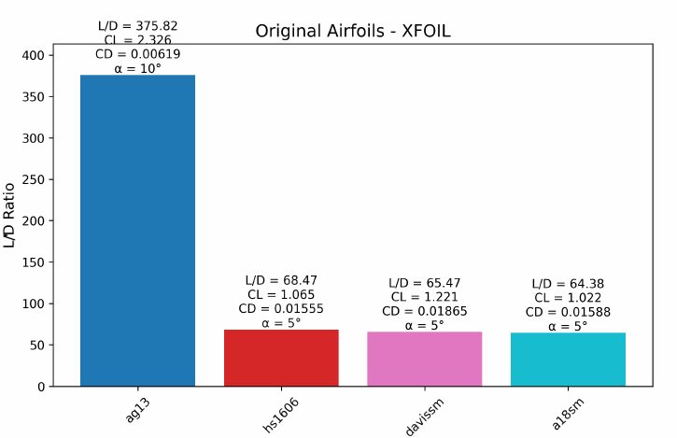
Fig. 1. XFOIL Lift-to-Drag ratio (L/D) for Top Four Contenders
As shown in Figure 2, results initially looked promising from the surrogate model but also appeared outlandish. More specifically, the L/D ratios are nearly four times higher as compared to the baseline.
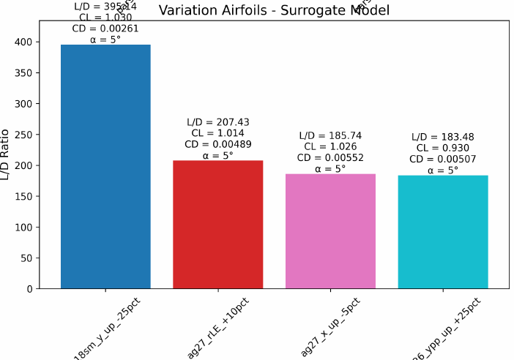

Fig. 2. AI Surrogate Model Results of the Top Four Variations
The results of the model (Figure 3) were revealed to be far too optimistic. The actual results of the airfoils were favored by the model where each has an L/D ratio of about 50, despite being predicted to be nearly four times that value.
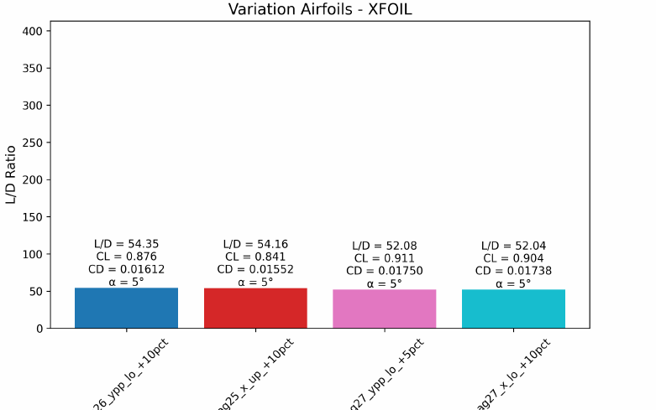

Fig. 3. Airfoil Results Derived by Surrogate AI Model
Further, the model consistently selected certain characteristics with high frequency. Specifically, the model favored increasing two parameters, lower crest curvature(ypp_lo) and upper crest X position(x_up). Due to this, the selected airfoils looked mostly similar, possibly leading to their similar performance when XFOIL was run. Additionally, the top five original airfoils and top five altered ones chosen by XFOIL reflects significant variation in original designs and similarity of predicted ones (Figure 3).

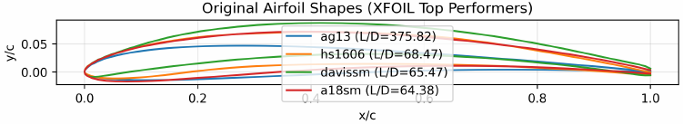
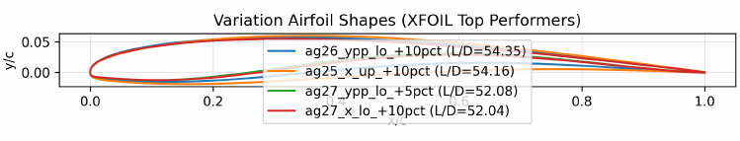
Fig. 4. Original vs Variation Airfoil Shapes

The findings suggest that the rapid computational speed allowed by AI can allow for improvements in airfoil design for specific criteria, and that reducing the variables to simple parameters increases the likelihood of improvement, but the models must be sufficiently trained and the datasets significantly large to yield valid results. The likely flaws of this model stem from the data sample. XFOIL often had issues processing some airfoils, and the data size itself was small— we likely saw overfitting to the 200-airfoil dataset. Additionally, the neural network did seem to reach connections, since it favored specific criteria (e.g., higher crest position). However, this led to homogeneity in the predictions for new airfoils, also likely due to an insufficiently diverse sample size. Additionally, this study emphasizes proof-of-concept and future models will need to be tested on a wider range of AoA and other variables. In this study, we emphasize if a designer has access to a sufficiently powerful computer to run data analysis, the desired outcomes can be achieved. Although our surrogate model had limitations, the novelty of our work is that the model ran orders of magnitude faster than XFOIL— while the original computations took hours, often with XFOIL freezes and the necessity of time-outs to throw out failed attempts, our model ran all 330 variation airfoils in seconds. To the best of our knowledge, we believe a model can be developed for use with specific alterations.
This study provides threefold recommendations. Firstly, we recommend developing the model on a computer with a significantly powerful graphics card and CPU, to scrape vast databases and perform XFOIL calculations simultaneously. Due to computing constraints, we could not process a sufficiently varied dataset. Secondly, we had success using PARSEC as a parameterization technique, but future research may find validity through other methods, perhaps Bezier curve fits or Sobieczky parameters. Thirdly, our method of varying airfoil parameters to reach a preferred design was not a precise search, but just a sweep of parameters. If one has a sufficiently well-trained model, a wiser technique may be to utilize binary search in airfoil variation to find a single, most optimal airfoil. Finally, we suggest performing a more thorough analysis of the final model’s computational needs on weaker computers, so the model may be sufficiently scalable to the needs of amateurs or non-professionals. With these considerations, we are confident that the advantages of AI airfoil design can be applied to smaller, more accessible scales.

References
[1] S. A. Brandt, Introduction to Aeronautics: A Design Perspective. AIAA, 2004.
[2] P. R. Spalart and V. Venkatakrishnan, “On the role and challenges of CFD in the aerospace industry,” The Aeronautical Journal, vol. 120, no. 1223, pp. 209–232, Jan. 2016, doi: 10.1017/aer.2015.10.
[3] M. Elrefaie, T. Ayman, M. Elrefaie, E. Sayed, M. Ayyad, and M. M. AbdelRahman, “Surrogate Modeling of the Aerodynamic Performance for Airfoils in Transonic Regime,” in AIAA SCITECH 2024 Forum, American Institute of Aeronautics and Astronautics, 2024. doi: 10.2514/6.2024-2220.
[4] P. Della Vecchia, E. Daniele, and E. DʼAmato, “An airfoil shape optimization technique coupling PARSEC parameterization and evolutionary algorithm,” Aerospace Science and Technology, vol. 32, no. 1, pp. 103–110, Jan. 2014, doi: 10.1016/j.ast.2013.11.006.
[5] N. P. Salunke, R. J. Ahamad, S. A. Channiwala, and S. A. Channiwala, “Airfoil parameterization techniques: A review,” American Journal of Mechanical Engineering, vol. 2, no. 4, pp. 99–102, 2014.
[6] J.-A. Désidéri, B. Abou El Majd, and A. Janka, “Nested and self-adaptive Bézier parameterizations for shape optimization,” Journal of Computational Physics, vol. 224, no. 1, pp. 117–131, May 2007, doi: 10.1016/j.jcp.2006.12.016.
[7] J. Liu et al., “AFBench: A Large-scale Benchmark for Airfoil Design,” Oct. 28, 2024, arXiv: arXiv:2406.18846. doi: 10.48550/arXiv.2406.18846.
[8] J. K. Cornelius, “PALMO: An OVERFLOW Machine Learning Airfoil Performance Database,” NACA 4-Series, Dec. 2024. Accessed: Oct. 24, 2025. [Online]. Available: https://ntrs.nasa.gov/citations/20240014546
[9] L. Wang et al., “A review of intelligent airfoil aerodynamic optimization methods based on data-driven advanced models,” Mathematics, vol. 12, no. 10, p. 1417, 2024.
[10] M. Selig, “UIUC Airfoil Data Site,” UIUC Applied Aerodynamics Group. Accessed: Oct. 23, 2025. [Online]. Available: https://m-selig.ae.illinois.edu/ads/coord_database.html

